Project Report

Course Name (NICF) | NICF Diploma in Infocomm Technology(Data)
Product Name (Marketing & Sales) | Professional Diploma in Data Science
Module Name (NICF) | NICF-Principles of Machine Learning(SF)
Product Name (Marketing & Sales) | Principles of Machine Learning

Student name |  | Assessor name
Goh Rui Kun |  | Ryan Suryanto
Date issued | Completion date |  | Submitted on
1st Feb 2021 | 4th Feb 2021 |  | 4th Feb 2021
Project title | News Categorization

Learner declaration
I certify that the work submitted for this assignment is my own and research sources are fully acknowledged.

Student signature: RK Date: 4th Feb 2021

Content
- Requirement Analysis 2
- Why Azure AML is a suitable solution for this scenario 3
- How to: Import and Prepare Data into Azure ML Studio 4
- How to: Preprocess Text 5
- How to: Extract Features from the DataSet
  - n-grams TF feature extraction 6
  - unigrams TF-IDF feature extraction 7
- How to: Train and evaluate models 8
- How to: Deploy trained models as web services
  - 5a. deploy web service with n-grams TF model 9
  - 5b. deploy web service with unigrams TF-IDF model 10

- Requirement Analysis
In this project, we will be using BBC (British Broadcasting Corporation) news contributed by D. Greene and P.Cunningham dataset. Every row of the dataset contains an article and a label which state which news category the article belongs to. There are 5 unique labels (or class) which is business, entertainment, politics, sports, and tech which is the target we trying to predict. The dataset we use is extract information from text which is known as text mining or text analytics. We will be comparing whether n-gram or unigram is better and efficient on the prediction outcome. This is also known as multiclass classification problem, which uses text mining and text analytics techniques in data preparation and preprocessing. We will be using multiclass classification and text analytics tools in Azure Machine Learning Studio (AML), prepared on n-gram and unigrams method. On each method, we will be using 4 different multiclass machine learning algorithms, to train, test, evaluate and choose the best model to deploy it as web service. After which we will test the web services using n-gram and unigram. We will create the experiment with predictive features in AML using R, features extraction from text using bag of words approach of uni-gram and bi-gram, computation of term weights (TF, IDF, TF-IDF) as well as document-term matrix (DTF), building of multiclass classification models using different machine learning algorithms, train, test, evaluate and compare the performance result of the models, finally have 2 web services that classify news or articles into 5 categories correctly.

- Why Azure AML is a suitable solution for this scenario.
In this project we are dealing with a multiclass text classification problem. AML provides a range of text analytics tools, algorithms for multiclass classification as well as web or API deployment tools. We will make use of this tools to build a solution for this problem. There are text analytics modules in AML that worked well with unstructured/structured text data. First the preprocess text module reduce noise, remove stop words, lemmatization, detect sentences, convert all text into lowercase, remove punctuation, remove numbers, remove special characters, remove duplicate characters etc. Next the feature hashing module which convert variable-length text documents into equal-length numeric feature vectors to support dimensionality reduction and fast lookup for feature weights. Next the filter-based feature selection module which identify the features in the dataset with the greatest predictive power and allow customization of feature scoring method and desired features input. For training the model, we will be using the tune model hyperparameters module to get the optimal values for the underlying learning algorithm parameters. This tuning module is especially useful when the dataset involves a lot of feature columns. This module performs a parameter sweep on the model to determine the optimum parameter settings and random sweep option to increase model performance. We will be using multiclass logistic regression, multiclass decision jungle, multiclass neural network, multiclass decision forest AML modules to create a model for prediction. Azure ML is very user-friendly and comes with a set of tools that are less restrictive. Azure tool has a lot of data and algorithms and give more accurate predictions. The tools make it easy to import training data and fine tune the result. We can use it and publish the data model as a web service.

- How to: Import and Prepare Data into Azure ML Studio
In this project, we will use the BBC news dataset which consists of 2225 documents form their website accordingly in 5 topical area from 2004 to 2005. The news is classified into 5 labels which is Business, Entertainment, Politics, Sports and Tech. The dataset contains 3 columns which No (containing serial number for the data), News (contain the text of the articles from the BBC news website) and Category (contains the labels).
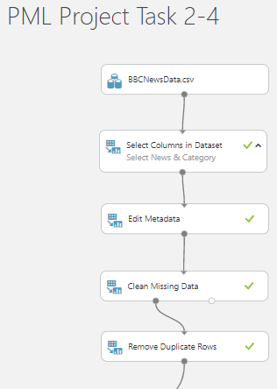

First load the dataset “BBCNewsData.csv” from local file, next visualize the dataset to check if there is any imbalanced data.
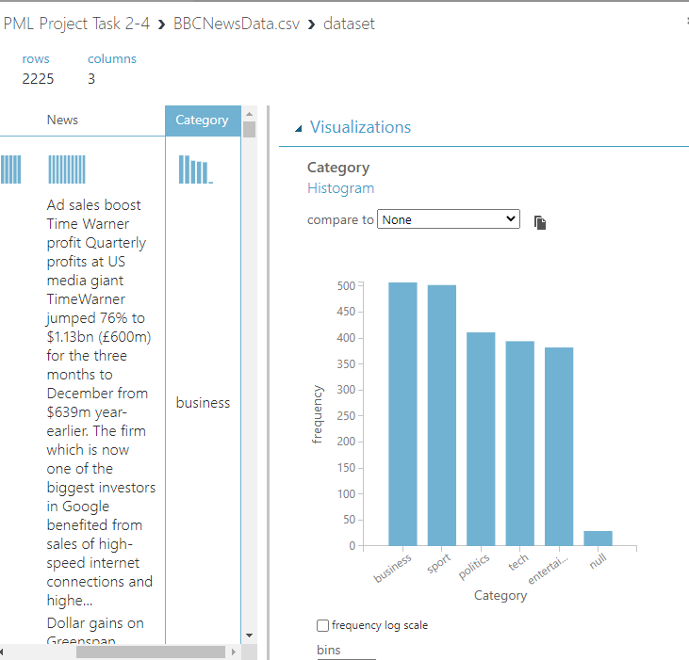

As above, we can view the distribution of “Category” looks acceptable within the range of 390 to 505. Thus, we can assume that the dataset is balance and do not require any further treatment.
Next, we will use “Select Columns in Dataset” module to select News and Category columns, “Edit Metadata” module to rename the columns as text_column and label_column respectively. After that we will run the experiment and visualize the data.
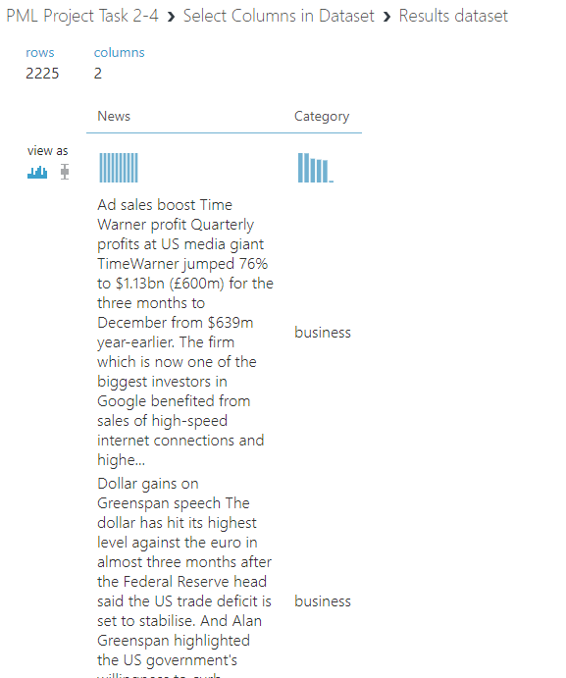

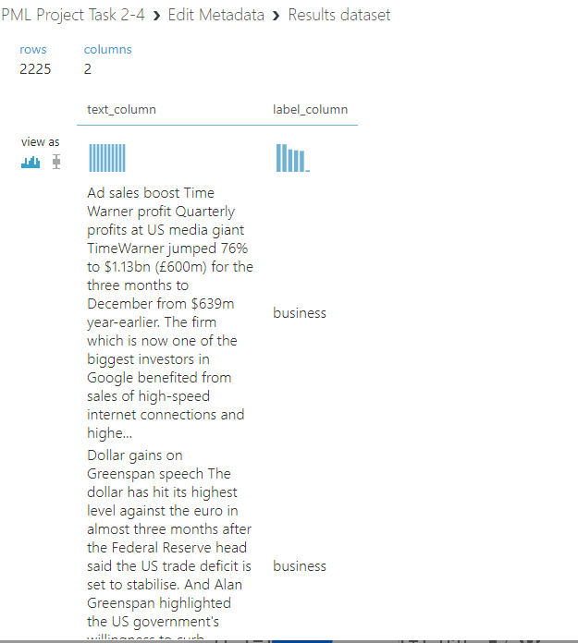

After visualizing the data, we found that the text_column have 2225 rows and 98 duplicated rows, the label_column contained 29 missing values.
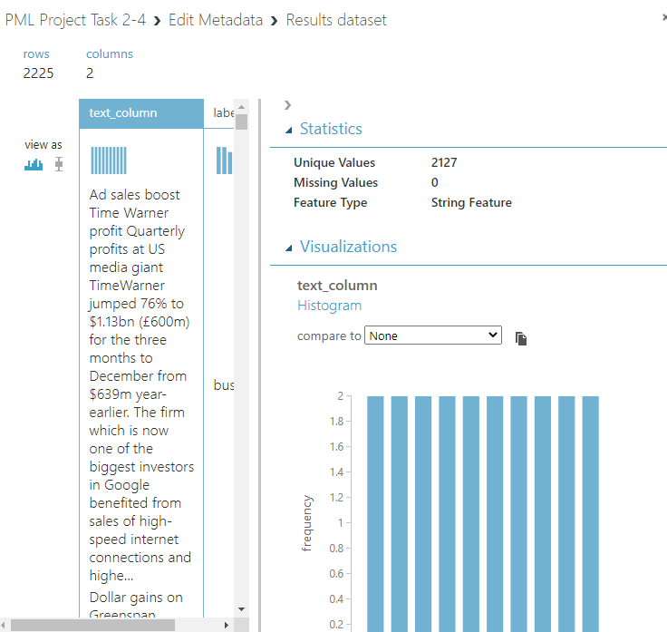

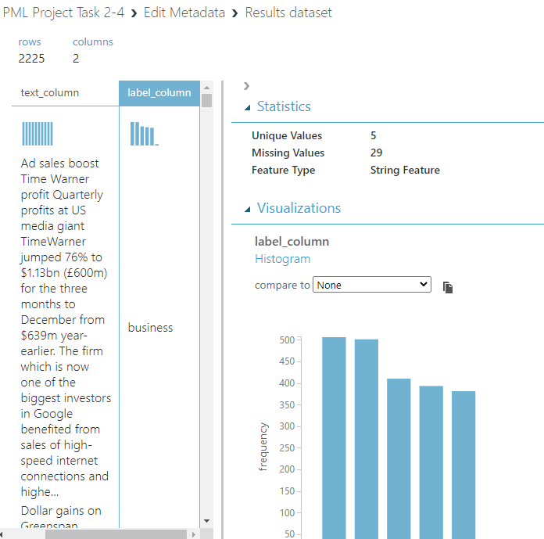

Next, we use the “Clean Missing Data” module to remove rows with missing values, then we use “Remove Duplicate Rows” module to remove 98 duplicate rows. Run the experiment and visualize.

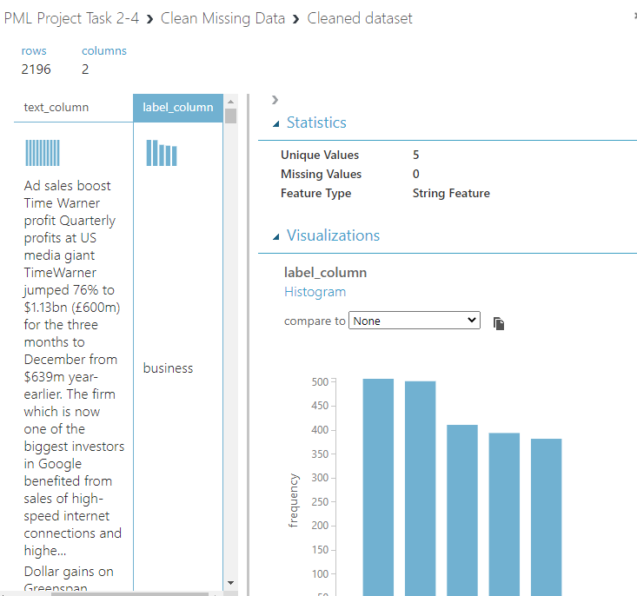
After cleaning the missing data, 29 rows have been removed.
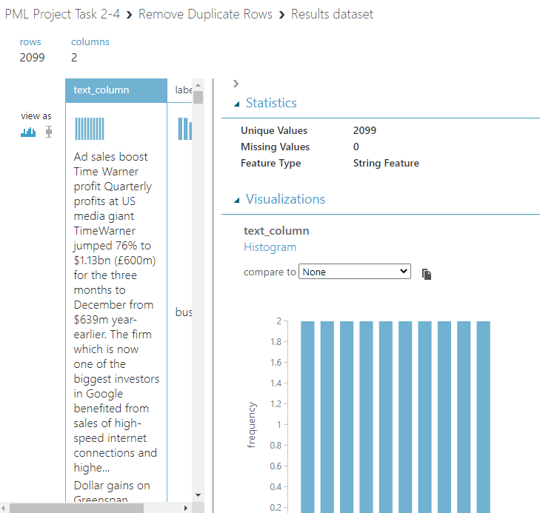

After removing duplicated rows, 96 rows have been removed, left with 2099 rows and 2 columns.

- How to: Preprocess Text
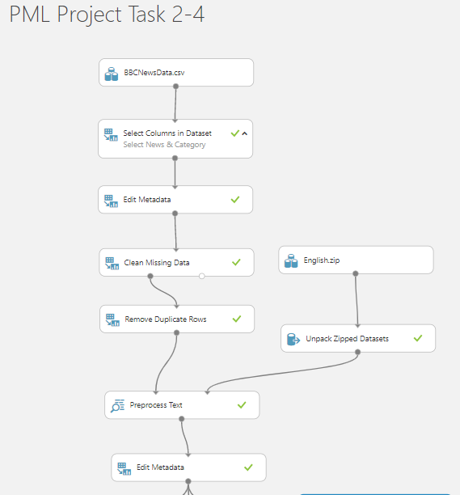

First, we use “Preprocess Text” module to perform pre-processing on text_column which can perform tasks include removing stop words, lemmatization, detect sentences, convert to lower case, remove punctuation, numbers, special characters and remove duplicate character. Next load “English. Zip” file which contain a list of 311 common words in English for the stop words. Next, we use the “Unpack Zipped Datasets” module and connect to right input port of the “Preprocess Text” module.
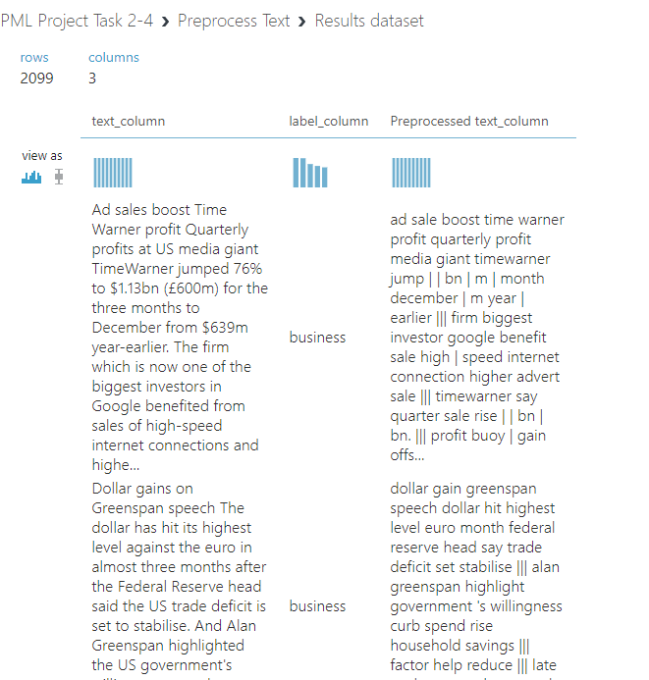

After running the experiment, visualize the data, there is an added new column “Preprocessed text_column”. Next, we use the “Edit Metadata” module to make the Preprocessed text-column to non-categorical and clear the features.
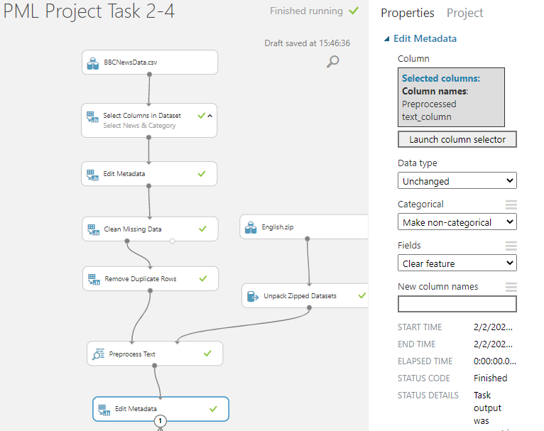

- How to: Extract Features from the DataSet
  - n-grams TF feature extraction
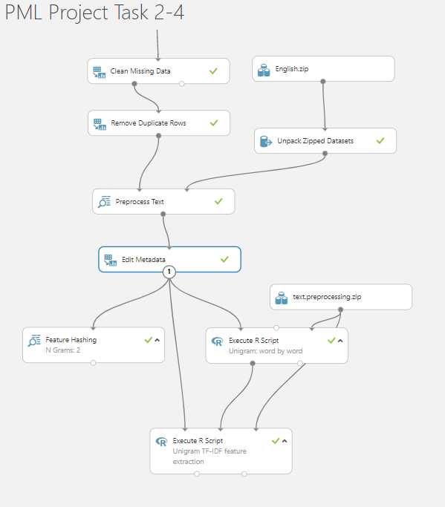

We will use “Feature Hashing” module to extract features as n-gram from the pre-processed text_column. It will convert variable-length text documents of n-grams to equal-length numeric feature vectors. It will also compute the Term Frequency for the n-gram extracted features. The objective of feature hashing is dimensionality reduction that makes the features weights faster at classification as it uses hash value instead of string comparison. We will set the number of hashing size to 15 and the number of n-gram to 2. This will generate a hash table that holds $2^{15}$ or 32,768 entries.
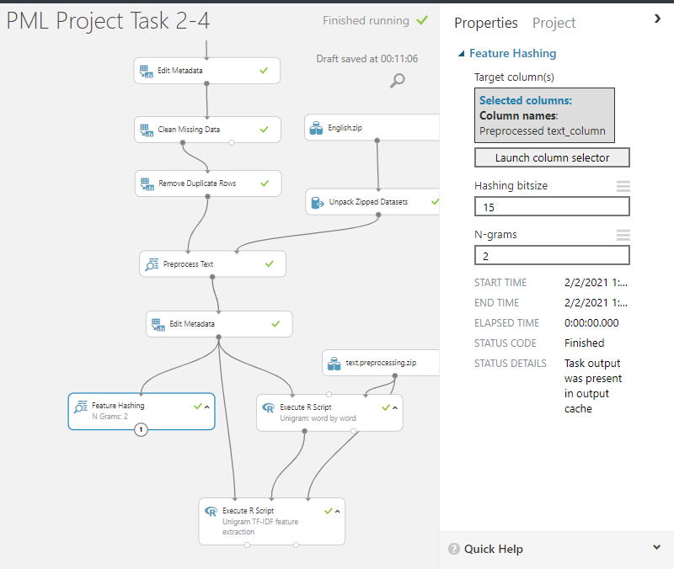

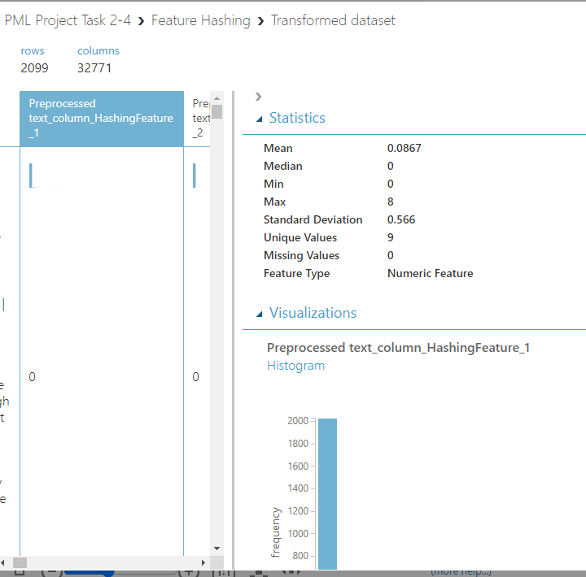
After running the experiment, visualize the data, there are a total of 32771 columns inclusive of the original 3 columns. The extracted features of n-gram are created as new columns and have been converted to numeric feature vectors by feature hashing. The column which represents the terms and each row represent the scored Term Frequency (TF).

  - unigrams TF-IDF feature extraction

We will load the “text. preprocessing. Zip” from local file which contains a list of R functions to compute DF, IDF, TF-IDF and transpose to a data frame. It will be connected to every “Execute R Script” module which the functions can be called. We will use custom code in the “Execute R Script” module that extract features as unigram from pre-processed text-column which creates a dictionary of the unigram and computes Document Frequency (DF) as well as Inverse Document Frequency (IDF) for the unigram-extracted features. The dictionary is created by extracting features from Preprocessed text_column for words length from 3 to 25 and appear in at least 9 documents.
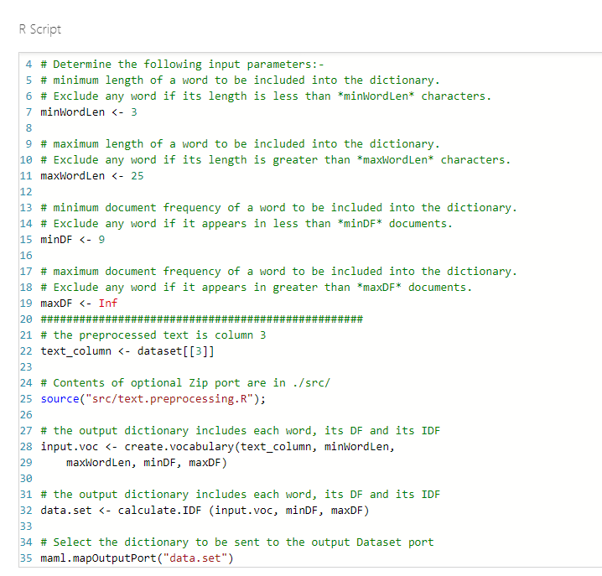
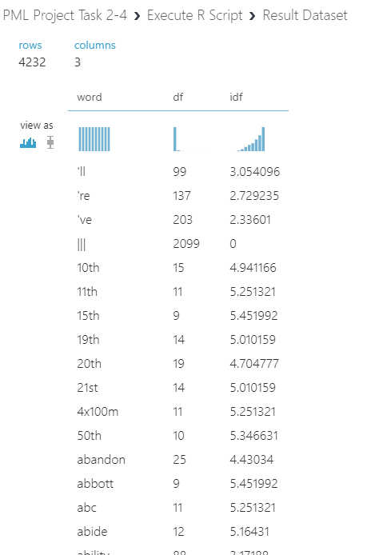

After running the experiment, visualize the data. There are 4232 rows that extracted from Pre-processed text_column and each row has the respective term weights in the measurement of DF and IDF.
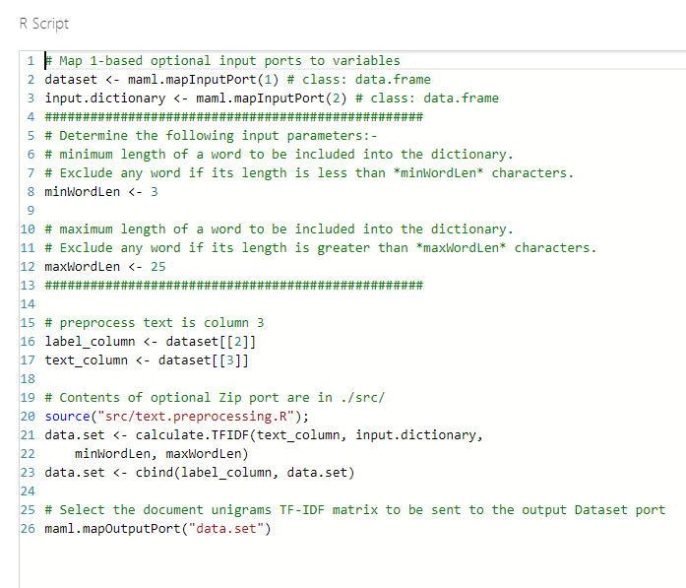
We will use the second “Execute R Script” module with custom code that transforms the dictionary into Term Document Matrix format by transpose and compute the Term Frequency-Inverse Document Frequency (TF-IDF).
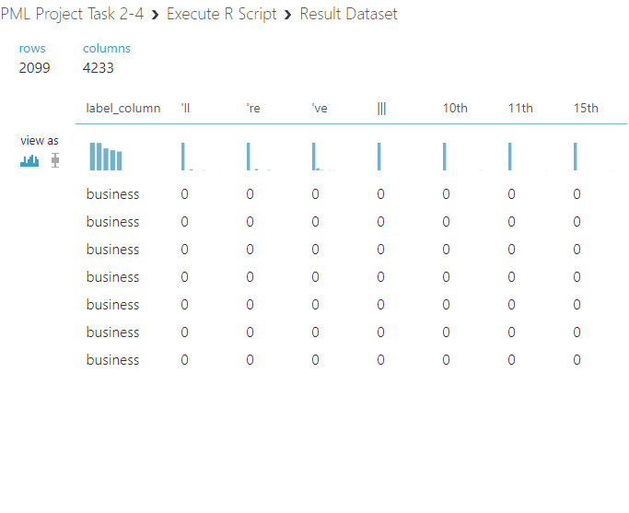
After running the experiment, visualize the data. There are 4233 columns inclusive of the label_column. The extracted features of unigram are transposed from rows into columns. The rows represent the documents by labels and the columns represents the terms with each value represent the scored TF-IDF of the extracted features. Each of the N-gram and Unigram will be saved as dataset for the next experiment.

- How to: Train and evaluate models
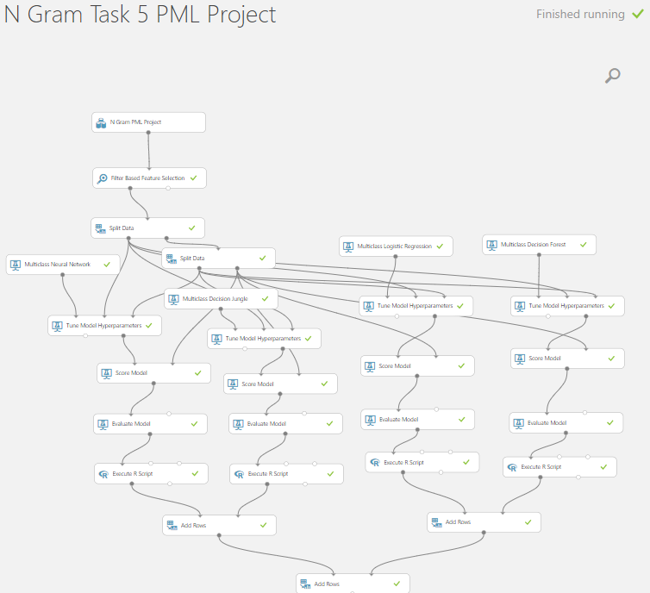

Create a new experiment, load N Gram dataset which was saved on the previous experiment. The classification time and complexity of the trained model depends on the number of features. For the text classification tasks, the number of features resulting from feature extraction is high because each word in the vocabulary and each n-gram is mapped to a feature. Out of the 32768 extracted hashing features, not all of them are equally important as some features have low score value in TF. We also want to avoid the effects of the curse of dimensionality and to reduce the computational complexity without harming classification accuracy. For selecting a more compact feature from the exhaustive list of extracted hashing features, we will use the “Filter Based Feature Selection” module. We will select the top 5000 most relevant features with respect to the label_column, we will be using Kendall correlation score function to rank the hashing in descending order. Next, we will use “Split Data” module to split the data into training set (70%) and testing set (30%). We will then add another “Split Data” module to split the testing data equally into validate and test data. Next, we will use the “Tune Model Hyperparameters” module to get the optimal values for the underlying learning algorithm parameters. We will use the setting as below.
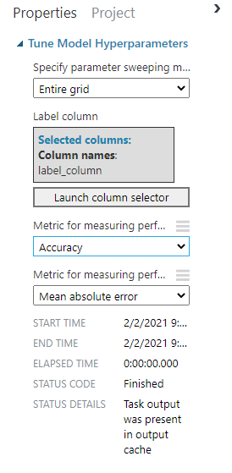
Next, we will use “Multiclass Neural Network” module to train the dataset with the setting as below.
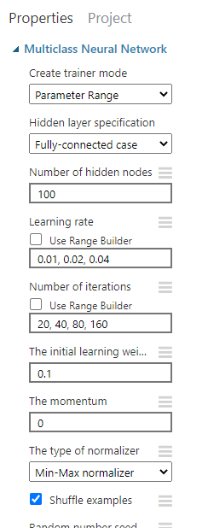

Next, we duplicate 3 more multiclass models (Decision Jungle, Logistic Regression, Decision Forest). Next, we will use the “Score Model” and “Evaluate Model” on each of the 4 models. Next, we will use “Execute R Script” module with custom code that consolidate all the metrics from each model in a single output for easier to compare.
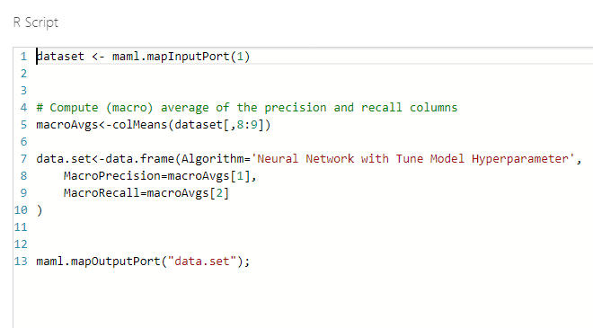

After running the experiment, visualize the result.

Multiclass Neural Network
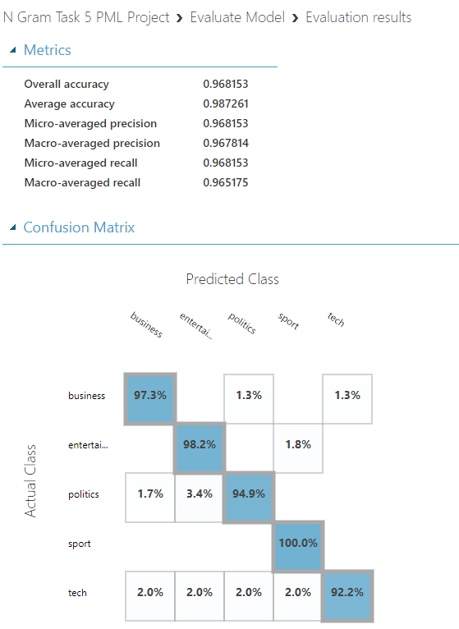

Multiclass Decision Jungle
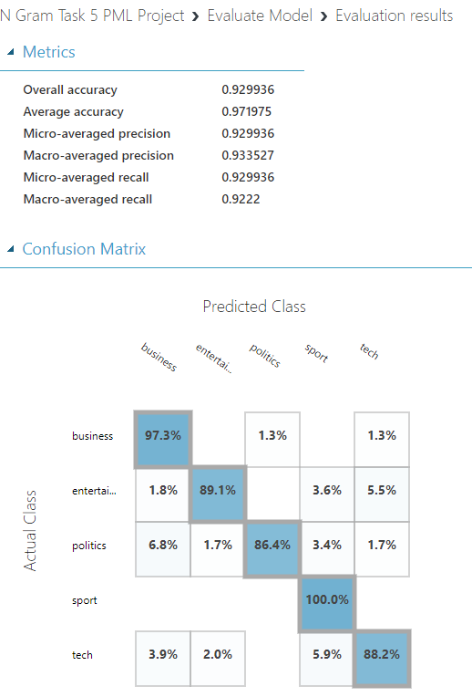

Multiclass Logistic Regression
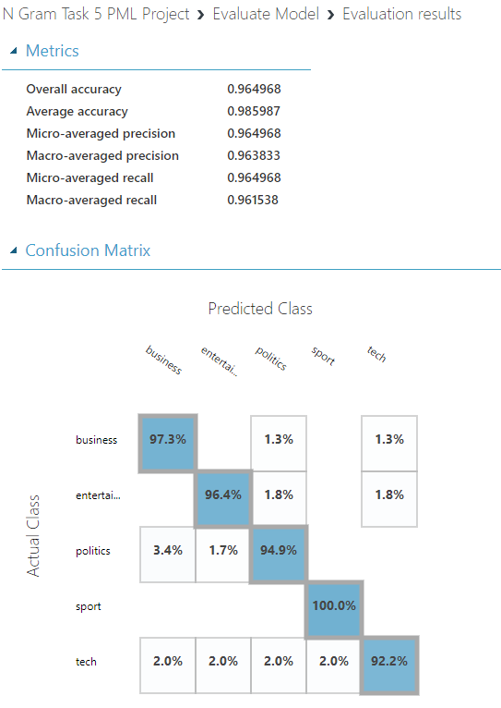

Multiclass Decision Forest
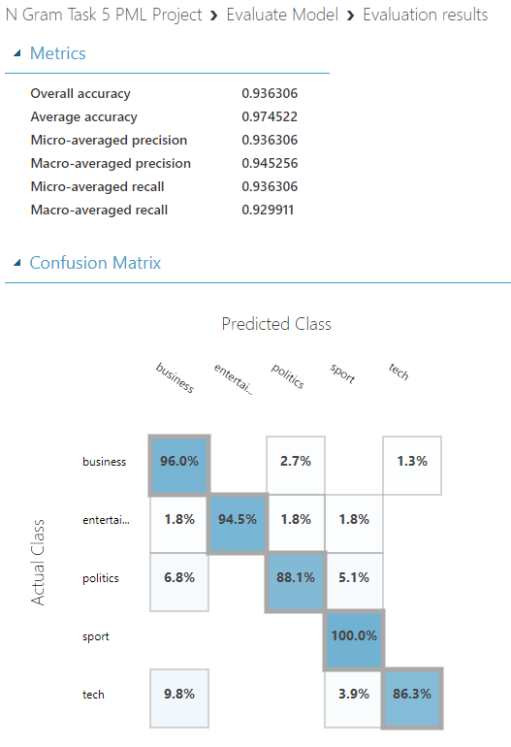

Next, we use “Add Rows” module to combine the evaluation metrics of all the models for comparison. After running the experiment, visualize the result.
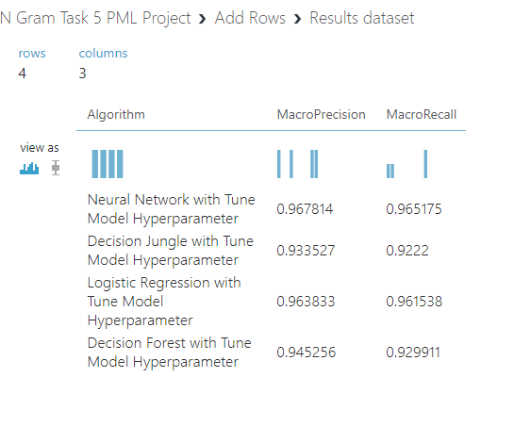
From the consolidated evaluation metrics, the Neural Network scored the highest in both the macro average precision and macro averaged recall at 0.97 for both. The second goes to the logistic Regression, third is Decision Forest and last is Decision Jungle. According to the metrics above, we chose the best model which is Neural Network.

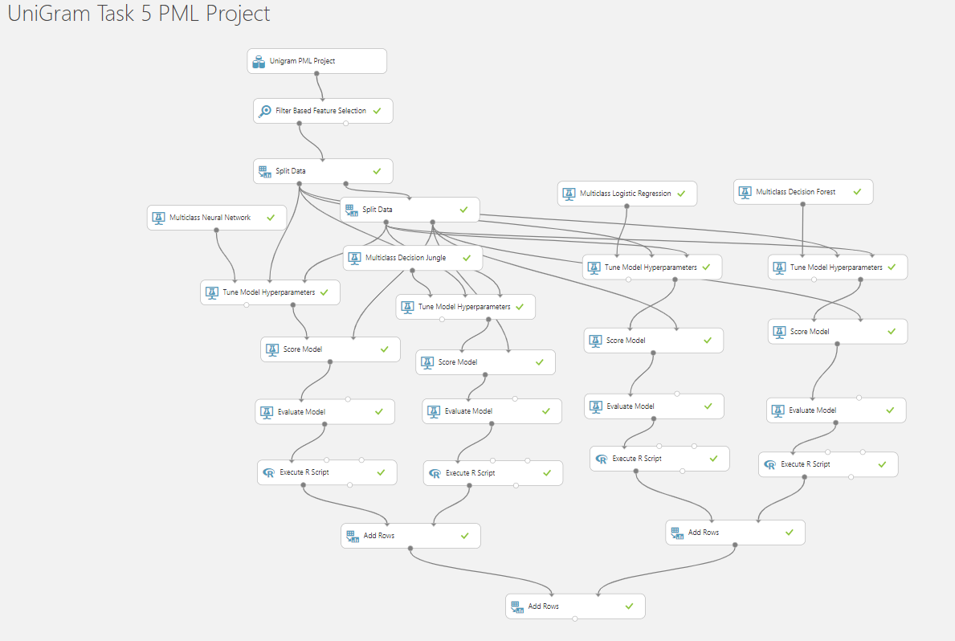

After completing the previous experiment, make a copy and save it as Unigram experiment. We will then change the dataset into Unigram and run the experiment. The filter-based Feature Selection model is optional as the dataset has less than 5000 rows.

Multiclass Neural Network
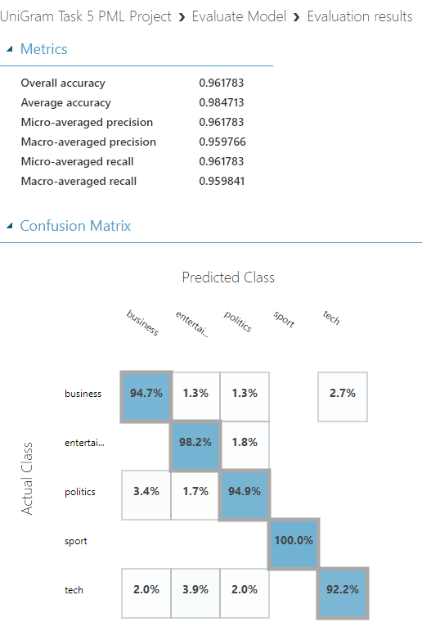

Multiclass Decision Jungle
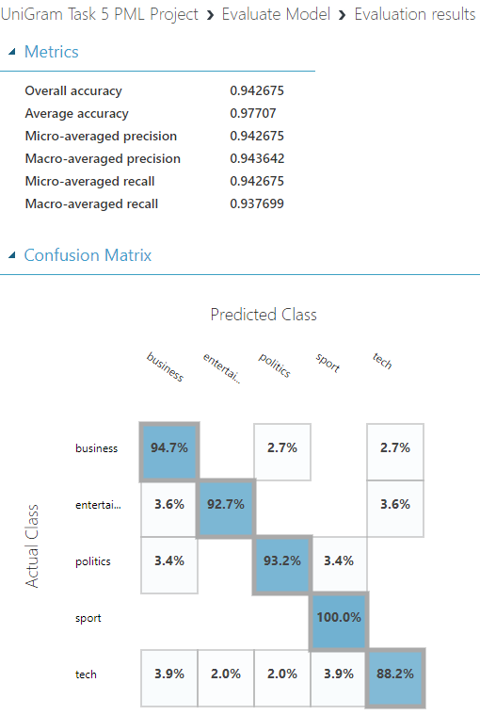

Multiclass Logistic Regression
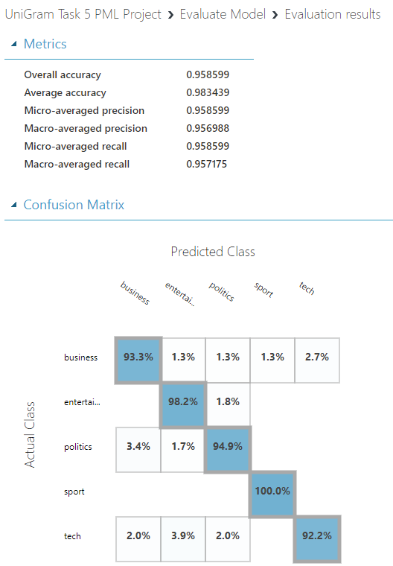

Multiclass Decision Forest
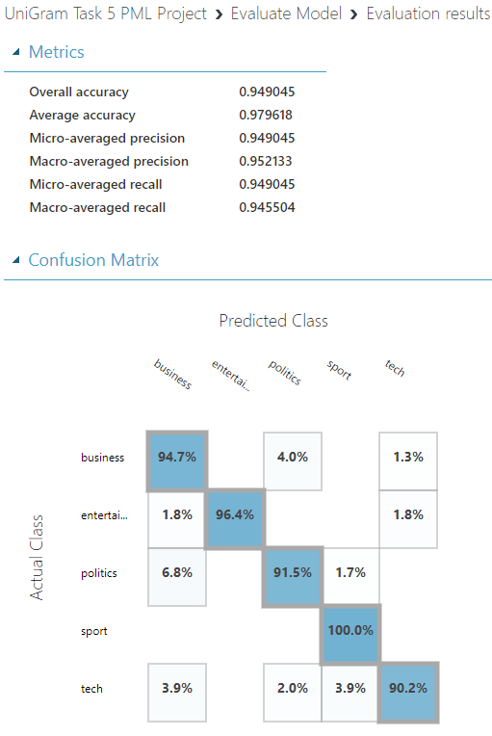

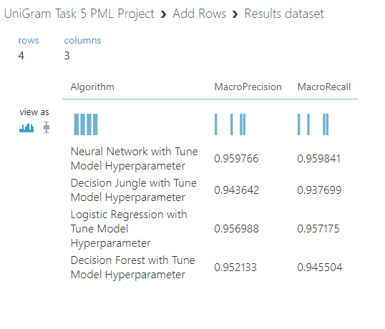
After running the experiment, visualize the result. From the consolidated evaluation metrics, Neural Network scored the highest for both macro averaged precision and macro averaged recall at 0.96 for both. Second goes to Logistic Regression, third is Decision Forest and last is Decision Jungles.

- How to: Deploy trained models as web services
  - 5a. deploy web service with n-grams TF model
Web service deployment for both models, n gram and unigram model will be done on separate experiment. We will create a new experiment, combine with the data, and model part using the best model that we concluded earlier which is the Multiclass Neural Network. Run the experiment and deploy it as web services.
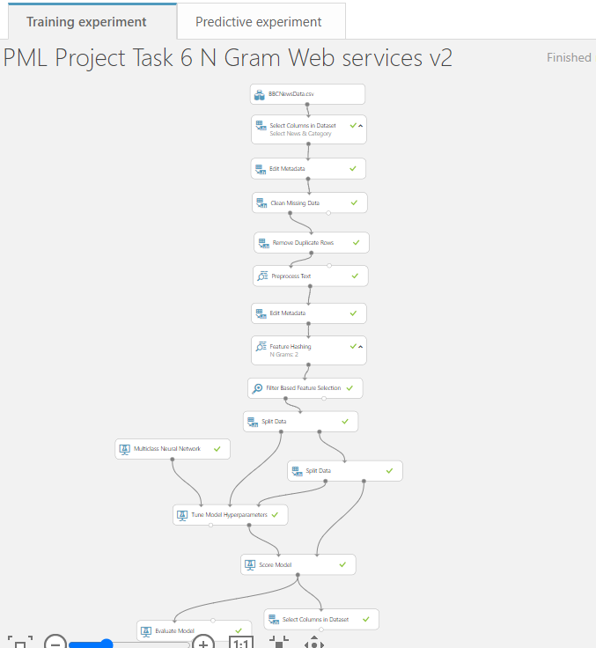

Next on the predictive experiment tab, we will include a “Select Columns in Dataset” module to only select output Scored Labels. Next, we modify the web services input which takes only News input. The “Filter Based Feature Selection” module will be removed, if not it will cause error. When done, save and run the experiment and deploy it as web service.
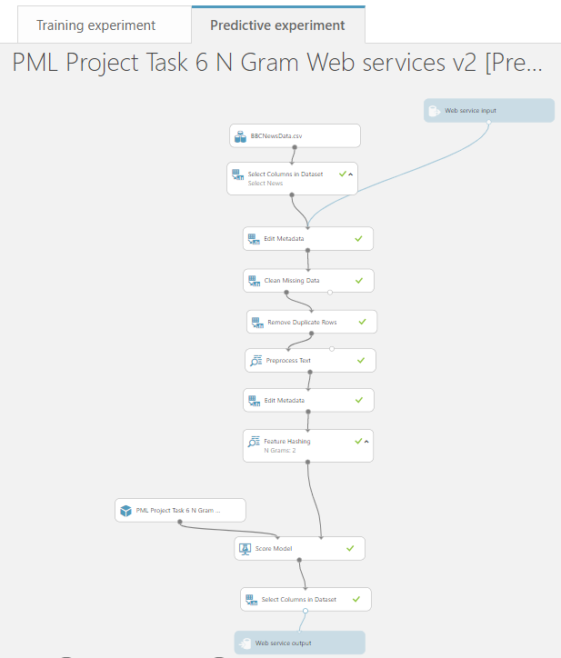

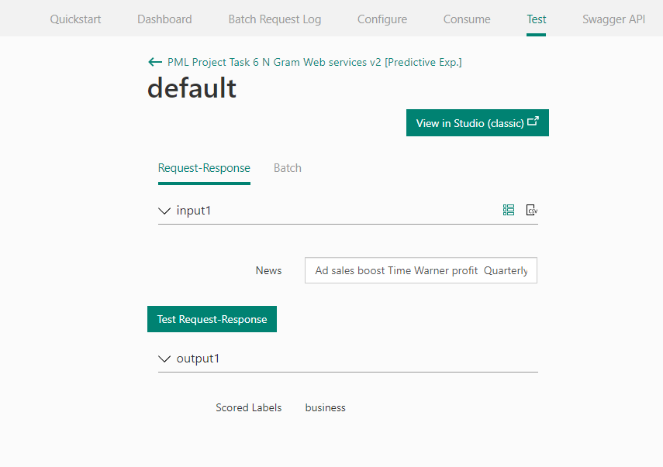

At the web service test page, provide a news article, and click on Test-Request-Response. It will output as what is predicted which indicated above: business.

  - 5b. deploy web service with unigrams TF-IDF model
Next create a new experiment, combine the data, and model part with the best model that compared on previous experiment which is the Multiclass Neural Network. Once done, save and run the experiment.

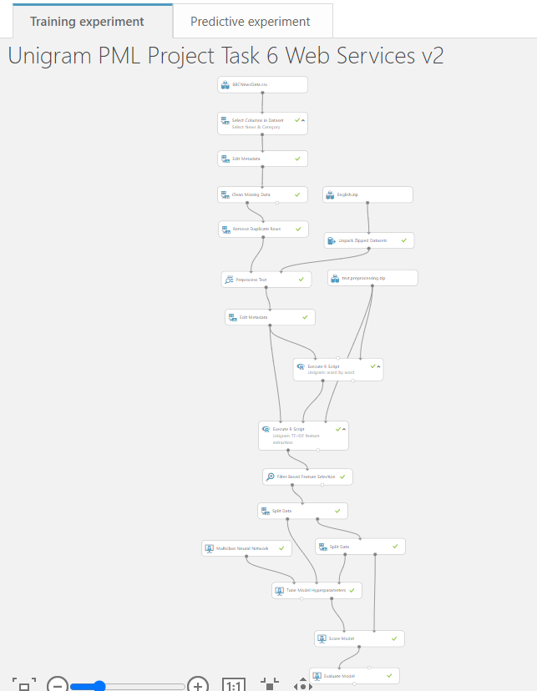

Next, click on deploy web services and the predictive experiment will be created in new tab.

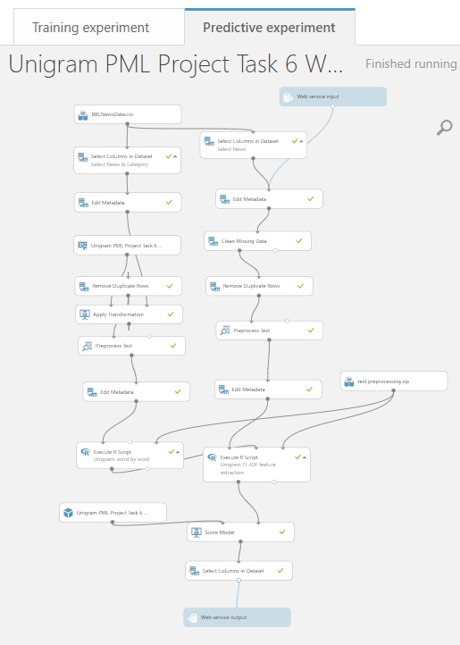

On the predictive experiment tab, add “Select Column in Dataset” module to the output and select only Scored Labels. Next modify the web services input which only take it News input. Next remove the English. Zip and Unpack Zipped Datasets module. We then duplicate another block to facilitate computation of TF-IDF for web service input. Once it is done, save and run the experiment. Next deploy it as web service.

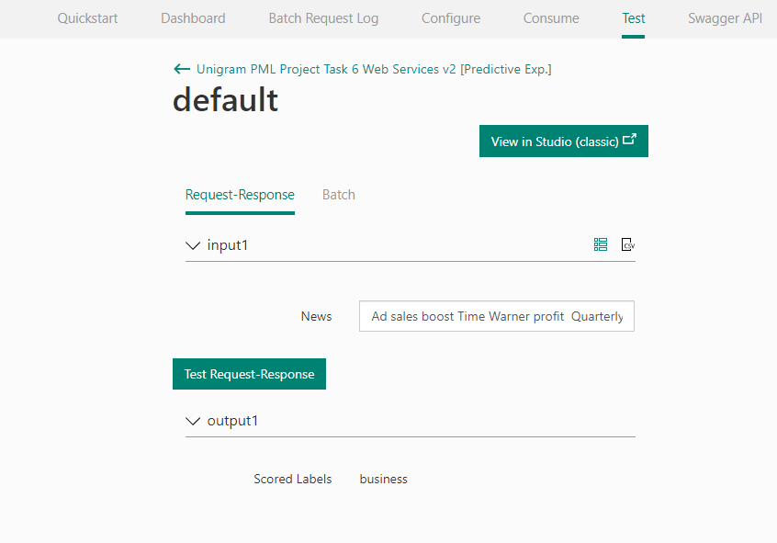

At the web service test page, provide a news article, and do a Request-Response test. It shows business as the predicted result. As above.

